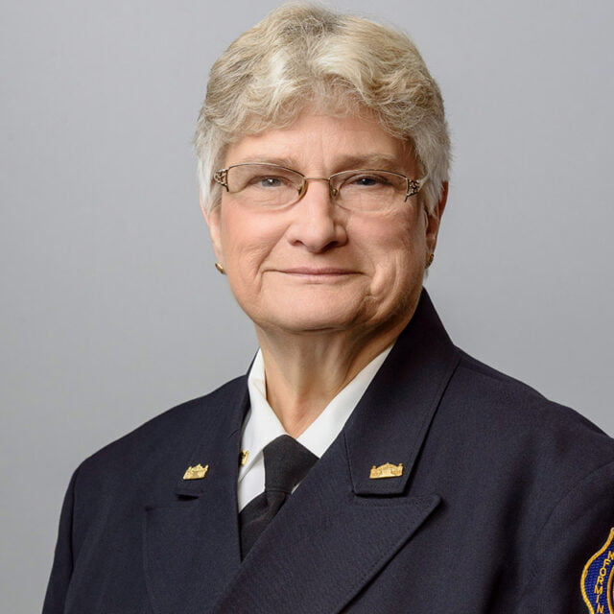
You are Invited To The
Testimonial for the FASNY Firefighters’ Home
Board of Trustees President

Marilyn l. Schrader

October 6, 2024 3:00 PM $40.00
Multi-Purpose Building at the FASNY Firefighters Home
125 Harry Howard Avenue Hudson New York 12534

Chicken and Pork BBQ with side dishes
Casual Attire
DEADLINE FOR RESERVATIONS 09/27/2024
********************************************Please cut off and Return with Payment to:
Vickie Dichian 1 Highpointe Drive Troy, NY 12182
Checks payable to: West Athens Lime Street Fire Co
Name _______________________________________
Email _________________________________________
$40 x _____ Total Amount $_______ Receipts will be acknowledged by email

